Install Printer in Windows 10 Via IP Address

Learn how to install a printer in Microsoft Windows 10 using an IP address using this step-by-step worksheet.

1. Select “**Start**” and type “**printers**” in the search box.
2. Choose “**Printers & scanners**“.
3. Select “**Add a printer or scanner**“.
4. Wait for the “**The printer that I want isn’t listed**” option to appear, then select it.  
   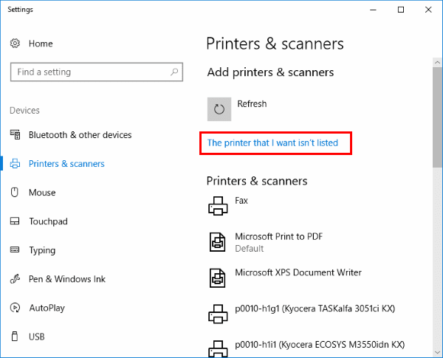
5. Select “**Add a printer using a TCP/IP address or hostname**” , then select “**Next**“.
6. Select “**TCP/IP Device**” in the “**Device type**” list.  
   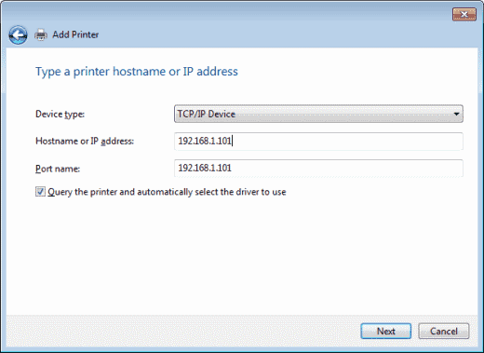
7. Type the **hostname** or the **IP address** of the printer. Select “**Next**“.
8. Windows should find the printer if the printer is on and configured correctly. You may have to specify more information. If prompted, Select the type of network adapter installed in the printer in the “**Device Type**” drop-down list. You can also click “**Custom**” to specify custom settings for the network printer. Select “**Next**“.

Windows will now walk you through installing the drivers for the printer. After that is complete, you should be able to send a print document to the printer via direct IP address.

Testing – Note that if the actual printer does not exist so that when you select “Test Print” no printing will occur, however if you select the printer and select “Open Queue” and the print document for the test print is present then you have completed this worksheet. You can select the test print and then select “Cancel” to remove the test print from the queue.

Printing to an actual printer – An actual printer in the classroom can be printed to after the student first adds a NAT network interface to their virtual machine running Windows 10. The student then can install the printer driver files manually after first checking the make and model of the printer and obtaining from the printer’s setup page the correct IP address. The student downloads the driver software from the vendor website and runs the printer software installation.

The student then finishes the installation by adding both the correct printer driver and the correct IP address for the printer in the classroom in the steps listed above. Installing the printer files manually first may be required if the driver files are not available via Windows update.